Sunday | Monday | Tuesday | Wednesday | Thursday | Friday | Saturday
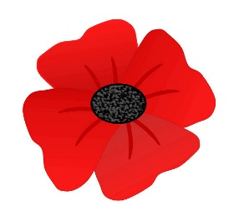 |  |  |  | 1  Pizza | 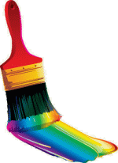  2  Art Club  GR. 4&5 | 3
4 | 5 | 6  Pita Pit | 7 | 8  Pizza  Remembrance Day Ceremony at 11:00 | 9  No School | 10
11 | 12  Remembrance Day  No School | 13  Pita Pit | 14 | 15  Pizza  Jersey Day- you are welcome to wear your jersey to school today | 16  Art Club  Gr. 4 & 5 | 17
18 | 19  Book Fair Begins this week- Library closed. | 20  Pita Pit  Report Cards go  Home.  Milk orders go home. | 21 | 22  Pizza  Parent- teacher interviews. 5:00pm to 7:00pm | 23  No School  Parent teacher interviews 9:00 am to 12:00 | 24
25 | 26 | 27  Pita Pit | 28 | 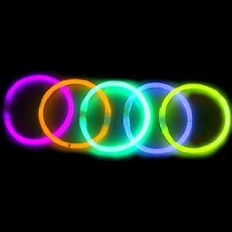  29  Pizza  Public Meeting 6:30pm –sustainability study | 30  Art Club , Great Canadian Bagel  Glow Party 5:30-7:00

